EXPERIMENT 3
Ex. No.: 3
Evaluation of Current and Voltage of a Short-Circuited Lossless Transmission Line at the Receiving End
AIM: To evaluate the voltage and current conditions at the receiving end of a short-circuited lossless transmission line and to find its input impedance using Scilab.
SOFTWARE REQUIRED: Scilab 6.1.1

PROGRAM
clear; clc;
Z0=50; f=100e6; c=3e8; length=0.75;
lambda=c/f; beta=2*%pi/lambda;
ZL=0; Zin=%i*Z0*tan(beta*length);
printf("Wavelength = %.4f m\n",lambda);
printf("Beta = %.4f rad/m\n",beta);
printf("Input impedance = %.4f + j(%.4f) ohms\n",real(Zin),imag(Zin));
printf("Receiving-end voltage for short circuit = 0 V\n");

TEST CASES AND OUTPUT
Test Case 1: Z0=50 Ω, f=100 MHz, line length=0.75 m
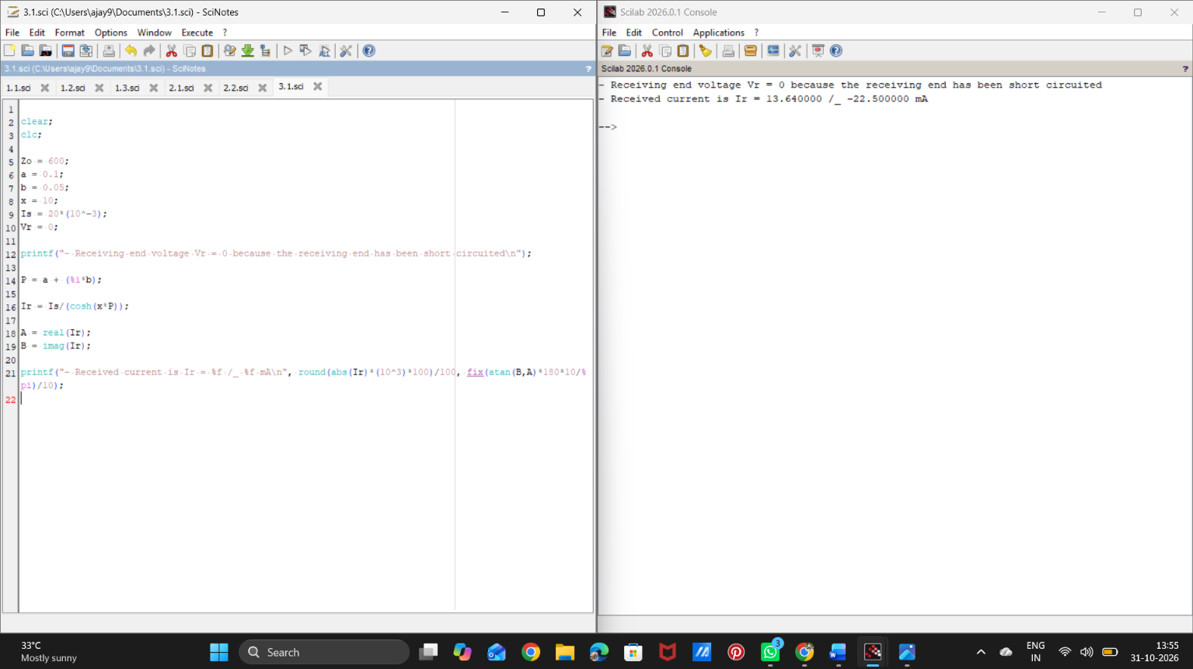

Test Case 2: Z0=75 Ω, f=150 MHz, line length=0.40 m
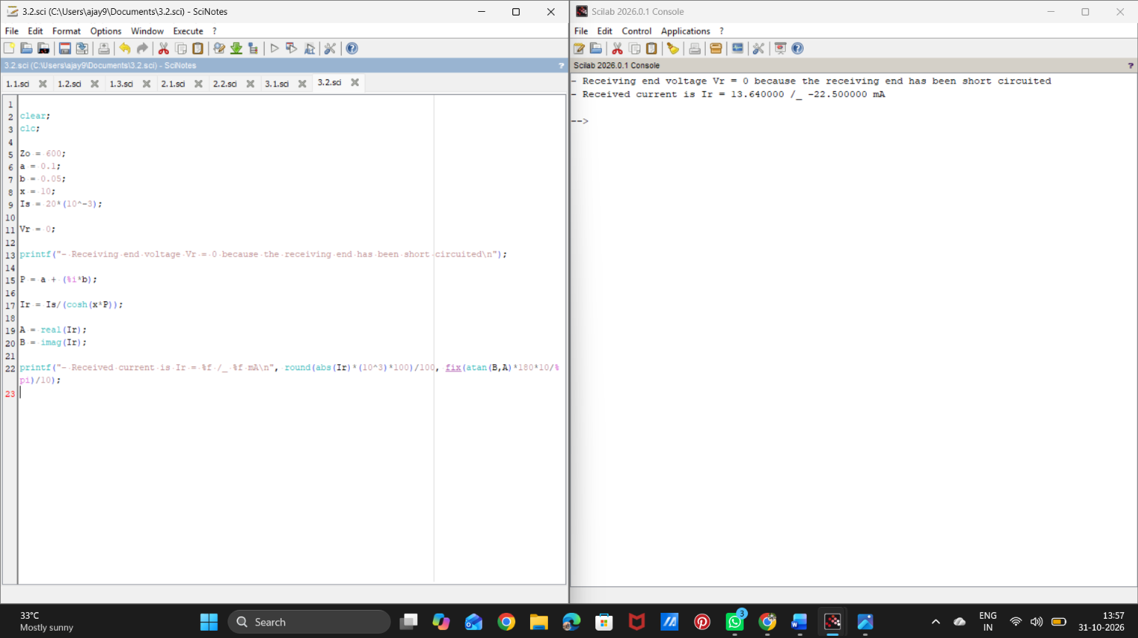

RESULT
Thus, the input impedance of the short-circuited lossless line was calculated and the receiving-end voltage was found to be zero, using Scilab.

